Date: 13.11.2024

T.Yuvasree_B.Tech-AI&DS

**DSA Coding Problems**

**Set – 4**

1. **Kth Smallest Number:**

Given an array **arr[]** and an integer **k** where k is smaller than the size of the array, the task is to find the **kth smallest** element in the given array.

**Note:** Don't solve it using the inbuilt sort function.

**Input:** arr[] = [7, 10, 4, 3, 20, 15], k = 3

**Output:** 7

**Code:**

public class Main {

public static void main(String[] args) {

int[] arr = {7, 10, 4, 3, 20, 15};

int k = 3;

int result = Solution.kthSmallest(arr, k);

System.out.println("The " + k + "-th smallest element is: " + result);

}

}

class Solution {

public static int kthSmallest(int[] arr, int k) {

int temp;

for (int i = 0; i < arr.length - 1; i++) {

for (int j = i + 1; j < arr.length; j++) {

if (arr[i] >= arr[j]) {

temp = arr[i];

arr[i] = arr[j];

arr[j] = temp;

}

}

}

return arr[k - 1];

}

}

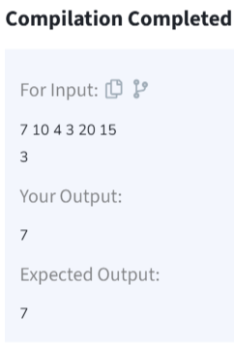

**Time Complexity: O(n^2)**

1. **Minimize the Height 2’s**

Given an array **arr[]** denoting heights of **N** towers and a positive integer **K.**

For **each**tower, you must perform **exactly one** of the following operations **exactly once**.

**Increase**the height of the tower by **K**

**Decrease**the height of the tower by **K**

Find out the **minimum**possible difference between the height of the shortest and tallest towers after you have modified each tower.

You can find a slight modification of the problem [here](https://practice.geeksforgeeks.org/problems/minimize-the-heights-i/1/).  
**Note:** It is **compulsory**to increase or decrease the height by K for each tower. **After** the operation, the resultant array should **not** contain any **negative integers**

**Input:** k = 2, arr[] = {1, 5, 8, 10}

**Output:** 5

**Explanation:** The array can be modified as {1+k, 5-k, 8-k, 10-k} = {3, 3, 6, 8}.The difference between the largest and the smallest is 8-3 = 5.

**Code:**

class Solution {

int getMinDiff(int[] arr, int k) {

int n = arr.length;

Arrays.sort(arr);

int res = arr[n - 1] - arr[0];

for (int i = 1; i < arr.length; i++) {

if (arr[i] - k < 0)

continue;

int minH = Math.min(arr[0] + k, arr[i] - k);

int maxH = Math.max(arr[i - 1] + k, arr[n - 1] - k);

res = Math.min(res, maxH - minH);

}

return res;

}

}

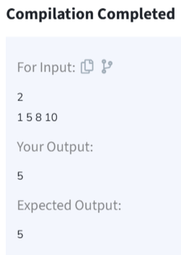

**Time Complexity: O(nlogn)**

1. **Parenthesis Checker:**

You are given a string s representing an expression containing various types of brackets: {}, (), and []. Your task is to determine whether the brackets in the expression are balanced. A balanced expression is one where every opening bracket has a corresponding closing bracket in the correct order.

**Input:** s = "{([])}"

**Output:** true

**Code:**

class Solution {

static boolean isParenthesisBalanced(String s) {

Stack<Character> stack = new Stack<>();

for (char ch : s.toCharArray()) {

if (ch == '{' || ch == '[' || ch == '(') {

stack.push(ch);

}

else if (ch == '}' || ch == ']' || ch == ')') {

if (stack.isEmpty()) {

return false;

}

char top = stack.pop();

if ((ch == '}' && top != '{') ||

(ch == ']' && top != '[') ||

(ch == ')' && top != '(')) {

return false;

}

}

}

return stack.isEmpty();

}

}

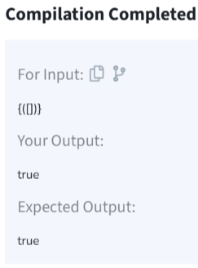

**Time Complexity: O(n)**

1. **Equilibrium Point:**

Given an array**arr**of non-negative numbers. The task is to find the first **equilibrium point** in an array. The equilibrium point in an array is an index (or position) such that the sum of all elements beforethat index is the same as the sumof elements afterit.

**Note:** Return equilibrium point in 1-based indexing. Return -1 if no such point exists.

**Input:** arr[] = [1, 3, 5, 2, 2]  
**Output:** 3

**Explanation:** The equilibrium point is at position 3 as the sum of elements before it (1+3) = sum of elements after it (2+2).

**Code:**

class Solution {

// Function to find equilibrium point in the array.

public static int equilibriumPoint(int arr[]) {

int totalSum = 0;

for (int num : arr) {

totalSum += num;

}

int leftSum = 0;

for (int i = 0; i < arr.length; i++) {

int rightSum = totalSum - leftSum - arr[i];

if (leftSum == rightSum) {

return i + 1;

}

leftSum += arr[i];

}

return -1;

}

}

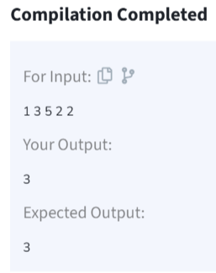

**Time Complexity: O(n)**

1. **Binary Search:**

**Code:**

import java.io.*;

class BinarySearch {

int binarySearch(int arr[], int x)

{

int low = 0, high = arr.length - 1;

while (low <= high) {

int mid = low + (high - low) / 2;

if (arr[mid] == x)

return mid;

if (arr[mid] < x)

low = mid + 1;

else

high = mid - 1;

}

return -1;

}

public static void main(String args[])

{

BinarySearch ob = new BinarySearch();

int arr[] = { 2, 3, 4, 10, 40 };

int n = arr.length;

int x = 10;

int result = ob.binarySearch(arr, x);

if (result == -1)

System.out.println(

"Element is not present in array");

else

System.out.println("Element is present at "

+ "index " + result);

}

}

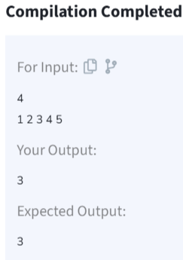

**Time Complexity: O(log n)**

1. **Next Greater Element:**

Given an array **arr[ ]** of integers, the task is to find the next greater element for each element of the array in order of their appearance in the array. Next greater element of an element in the array is the nearest element on the right which is greater than the current element.  
If there does not exist next greater of current element, then next greater element for current element is -1. For example, next greater of the last element is always -1.

**Input**: arr[] = [1, 3, 2, 4]

**Output**: [3, 4, 4, -1]

**Explanation**: The next larger element to 1 is 3, 3 is 4, 2 is 4 and for 4, since it doesn't exist, it is -1.

**Code**:

class Solution {

// Function to find the next greater element for each element of the array.

public ArrayList<Integer> nextLargerElement(int[] arr) {

int n = arr.length;

int[] result = new int[n];

Arrays.fill(result, -1);

Stack<Integer> stack = new Stack<>();

for (int i = n - 1; i >= 0; i--) {

while (!stack.isEmpty() && stack.peek() <= arr[i]) {

stack.pop();

}

if (!stack.isEmpty()) {

result[i] = stack.peek();

}

stack.push(arr[i]);

}

return result;

}

}

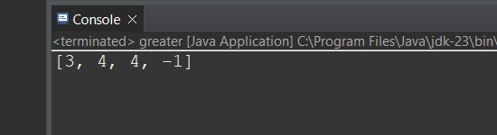

**Time Complexity: O(n)**

1. **Union Of Two Arrays:**

Given two arrays **a[]** and **b[]**,the task is to find the number of elements in the union between these two arrays.

The Union of the two arrays can be defined as the set containing distinct elements from both arrays. If there are repetitions, then only one element occurrence should be there in the union.

Note:Elements are not necessarily distinct.

**Input:** a[] = [1, 2, 3, 4, 5], b[] = [1, 2, 3]

**Output:** 5

**Explanation:** 1, 2, 3, 4 and 5 are the elements which comes in the union set of both arrays. So count is 5.

**Code:**

class Solution {

public static int findUnion(int a[], int b[]) {

HashSet<Integer> uniqueElements = new HashSet<>();

for (int num : a) {

uniqueElements.add(num);

}

for (int num : b) {

uniqueElements.add(num);

}

return uniqueElements.size();

}

}

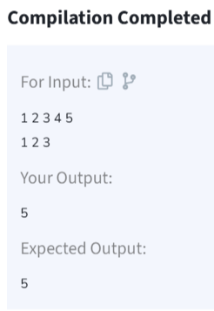

**Time Complexity: O(n+m)**